Plane in Space
# Source: AI Source: Provided by: [Data Path: Persons Table -> ID Column: 1, Name_En Column: Motasem Essam] -> From: [ChatGPT] on [7/25/2026]
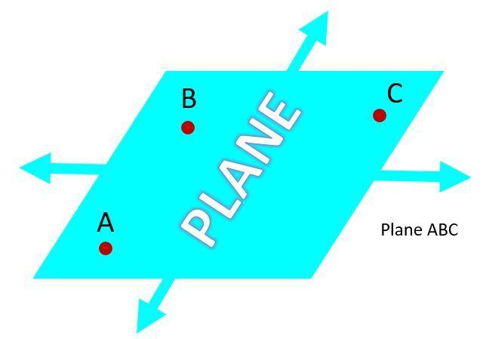
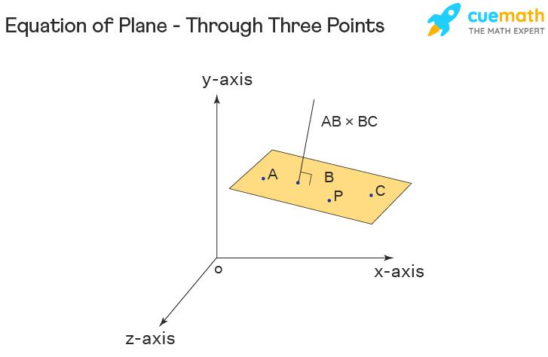
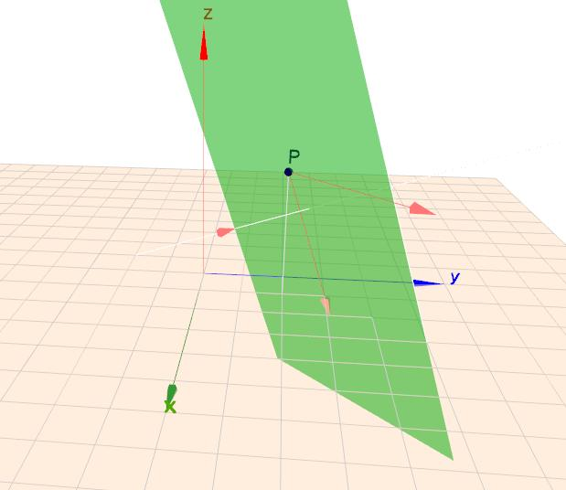

Definition
# Source: AI Source: Provided by: [Data Path: Persons Table -> ID Column: 1, Name_En Column: Motasem Essam] -> From: [ChatGPT] on [7/25/2026]
A plane in space is a flat, two-dimensional surface that extends infinitely in all directions within three-dimensional space.
A plane has length and width but no thickness. It contains infinitely many points and lines, and it is determined uniquely by three non-collinear points.
In solid geometry, a plane is often represented by a slanted parallelogram, although the actual plane extends infinitely beyond the drawn region.
Planes are commonly named using a Greek letter, such as $α$, $β$, or $γ$, or by three non-collinear points lying on the plane, such as plane $ABC$.

Simple Definition
# Source: AI Source: Provided by: [Data Path: Persons Table -> ID Column: 1, Name_En Column: Motasem Essam] -> From: [ChatGPT] on [7/25/2026]
A plane in space is an infinitely large, perfectly flat surface.
Examples that approximate a plane include:
- A tabletop.
- A wall.
- A sheet of paper.
- The surface of a still lake.
These physical objects are finite and may have thickness, but they help visualize the mathematical idea of a plane.

Key Characteristics
# Source: AI Source: Provided by: [Data Path: Persons Table -> ID Column: 1, Name_En Column: Motasem Essam] -> From: [ChatGPT] on [7/25/2026]
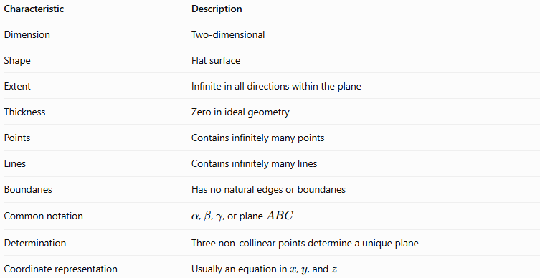
Characteristic | Description
Dimension | Two-dimensional
Shape | Flat surface
Extent | Infinite in all directions within the plane
Thickness | Zero in ideal geometry
Points | Contains infinitely many points
Lines | Contains infinitely many lines
Boundaries | Has no natural edges or boundaries
Common notation | $α$, $β$, $γ$, or plane $ABC$
Determination | Three non-collinear points determine a unique plane
Coordinate representation | Usually an equation in $x$, $y$, and $z$

Geometric Representation
# Source: AI Source: Provided by: [Data Path: Persons Table -> ID Column: 1, Name_En Column: Motasem Essam] -> From: [ChatGPT] on [7/25/2026]
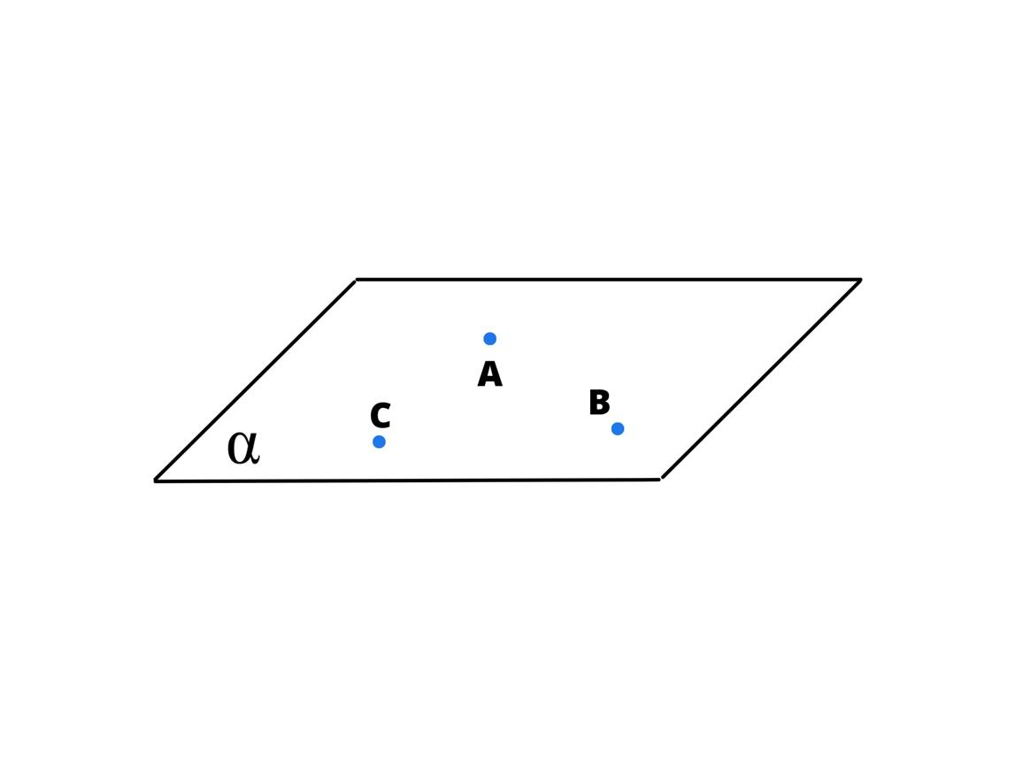
A plane is often drawn as a parallelogram to represent a portion of its infinite surface.
Plane $α$ containing three non-collinear points $A$, $B$, and $C$.
The parallelogram is only a visual representation. The plane itself has no edges and continues indefinitely in every direction along its surface.
Three non-collinear points determine a plane
Three points determine exactly one plane if they do not all lie on the same straight line.
- If $A$, $B$, and $C$ are non-collinear, they determine a unique plane $ABC$.
- If all three points lie on one line, infinitely many planes can contain that line.

Mathematical Representation and Formulas

A. General equation of a plane
# Source: AI Source: Provided by: [Data Path: Persons Table -> ID Column: 1, Name_En Column: Motasem Essam] -> From: [ChatGPT] on [7/25/2026]
In three-dimensional Cartesian coordinates, a plane can be represented by
$$\boxed{Ax+By+Cz+D=0}$$
where:
- $x,y,z$ are the coordinates of a point.
- $A,B,C$ are constants that determine the plane's orientation.
- $D$ determines its position relative to the coordinate origin.
- At least one of $A,B,C$ must be nonzero.
The vector
$$\boxed{n=\left(A,B,C\right)}$$
is called the normal vector of the plane. It is perpendicular to the plane.

B. A plane through a point with a normal vector
# Source: AI Source: Provided by: [Data Path: Persons Table -> ID Column: 1, Name_En Column: Motasem Essam] -> From: [ChatGPT] on [7/25/2026]
If the plane passes through $P_{0}\left(x_{0},y_{0},z_{0}\right)$ and has normal vector $n=\left(A,B,C\right)$, then
$$\boxed{A\left(x-x_{0}\right)+B\left(y-y_{0}\right)+C\left(z-z_{0}\right)=0}$$
This is called the point-normal form of the plane equation.

C. A plane determined by three points
# Source: AI Source: Provided by: [Data Path: Persons Table -> ID Column: 1, Name_En Column: Motasem Essam] -> From: [ChatGPT] on [7/25/2026]
Suppose three non-collinear points are
$$A\left(x_{1},y_{1},z_{1}\right), B\left(x_{2},y_{2},z_{2}\right), C\left(x_{3},y_{3},z_{3}\right).$$
Two direction vectors in the plane are
$$\overset{→}{AB}=B-A$$
and
$$\overset{→}{AC}=C-A.$$
A normal vector is obtained from their cross product:
$$\boxed{n=\overset{→}{AB}×\overset{→}{AC}}$$
Because the points are non-collinear, this cross product is nonzero. The resulting normal vector can be used in the plane equation.

D. Examples of coordinate planes
# Source: AI Source: Provided by: [Data Path: Persons Table -> ID Column: 1, Name_En Column: Motasem Essam] -> From: [ChatGPT] on [7/25/2026]
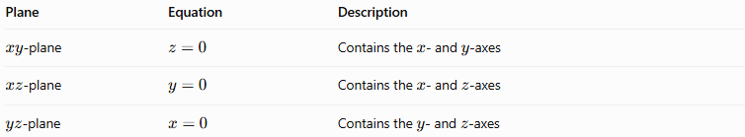
Plane | Equation | Description
$xy$-plane | $$z=0$$ | Contains the $x$- and $y$-axes
$xz$-plane | $$y=0$$ | Contains the $x$- and $z$-axes
$yz$-plane | $$x=0$$ | Contains the $y$- and $z$-axes
These three coordinate planes intersect at the origin and are pairwise perpendicular.

Worked Examples
# Source: AI Source: Provided by: [Data Path: Persons Table -> ID Column: 1, Name_En Column: Motasem Essam] -> From: [ChatGPT] on [7/25/2026]
Example 1: Identifying a plane from its equation
Consider the plane
$$2x+3y-z+6=0.$$
Identify its normal vector.
Comparing with the general equation
$$Ax+By+Cz+D=0,$$
we get
$$A=2, B=3, C=-1.$$
Therefore, the normal vector is
$$\boxed{n=\left(2,3,-1\right)}.$$
Example 2: Checking whether a point lies on a plane
Determine whether $P\left(1,2,3\right)$ lies on the plane
$$x+y+z=6.$$
Substitute the coordinates:
$$1+2+3=6.$$
The equation is satisfied.
Answer: The point $P\left(1,2,3\right)$ lies on the plane.
Example 3: Finding a plane through a point
Find the equation of a plane passing through $P\left(1,2,3\right)$ with normal vector
$$n=\left(2,-1,4\right).$$
Use the point-normal formula:
$$2\left(x-1\right)-\left(y-2\right)+4\left(z-3\right)=0.$$
Expand:
$$2x-2-y+2+4z-12=0.$$
Simplify:
$$\boxed{2x-y+4z-12=0}.$$
Example 4: Determining whether three points define a unique plane
Consider
$$A\left(0,0,0\right), B\left(1,0,0\right), C\left(0,1,0\right).$$
The direction vectors are
$$\overset{→}{AB}=\left(1,0,0\right)$$
and
$$\overset{→}{AC}=\left(0,1,0\right).$$
Their cross product is
$$\overset{→}{AB}×\overset{→}{AC}=\left(0,0,1\right).$$
Since the cross product is nonzero, the points are non-collinear and determine a unique plane.
All three points have $z=0$, so the plane is
$$\boxed{z=0}.$$
This is the $xy$-plane.

Comparison With Related Concepts
# Source: AI Source: Provided by: [Data Path: Persons Table -> ID Column: 1, Name_En Column: Motasem Essam] -> From: [ChatGPT] on [7/25/2026]
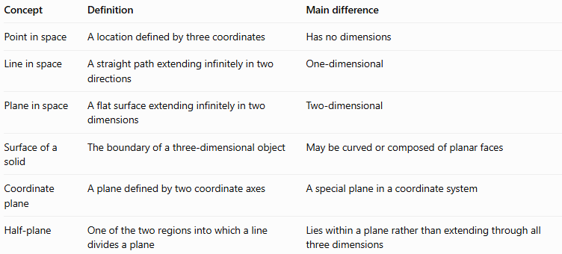
Concept | Definition | Main difference
Point in space | A location defined by three coordinates | Has no dimensions
Line in space | A straight path extending infinitely in two directions | One-dimensional
Plane in space | A flat surface extending infinitely in two dimensions | Two-dimensional
Surface of a solid | The boundary of a three-dimensional object | May be curved or composed of planar faces
Coordinate plane | A plane defined by two coordinate axes | A special plane in a coordinate system
Half-plane | One of the two regions into which a line divides a plane | Lies within a plane rather than extending through all three dimensions

Applications
# Source: AI Source: Provided by: [Data Path: Persons Table -> ID Column: 1, Name_En Column: Motasem Essam] -> From: [ChatGPT] on [7/25/2026]
Planes are fundamental in many mathematical and practical fields:
- Architecture and construction: representing walls, floors, ceilings, and flat structural surfaces.
- Computer graphics: defining surfaces, clipping regions, and object faces in three-dimensional scenes.
- Engineering: modeling flat components and analyzing intersections between surfaces.
- Analytic geometry: calculating distances, angles, and intersections in space.
- Physics: describing idealized surfaces and reference planes.
- 3D modeling: defining the faces of polyhedra and other geometric objects.

Key Points
# Source: AI Source: Provided by: [Data Path: Persons Table -> ID Column: 1, Name_En Column: Motasem Essam] -> From: [ChatGPT] on [7/25/2026]
- A plane is a flat, two-dimensional surface extending infinitely in its own directions.
- A plane has no thickness and no natural boundaries.
- Three non-collinear points determine exactly one plane.
- A plane can be represented by $Ax+By+Cz+D=0$.
- The vector $\left(A,B,C\right)$ is normal to the plane.
- The $xy$-, $xz$-, and $yz$-planes are the three coordinate planes.
- A plane is different from a finite flat face, although a face can lie on a plane.

Conclusion
# Source: AI Source: Provided by: [Data Path: Persons Table -> ID Column: 1, Name_En Column: Motasem Essam] -> From: [ChatGPT] on [7/25/2026]
A plane in space is one of the fundamental objects of solid geometry. It provides a way to describe flat two-dimensional regions within three-dimensional space and serves as the basis for studying lines, angles, intersections, and the faces of solids.
Planes can be represented visually, defined by points and vectors, or expressed algebraically through coordinate equations.

